**RAVEN P. AMPERE**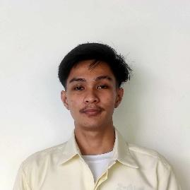

**09924313554**

[ravenampere0123@gmail.com](mailto:ravenampere0123@gmail.com)

**PERSONAL DATA**

Date of Birth: December 7, 2003

Place of Birth: Las pinas doctors

Religion: Iglesia Ni Cristo

Citizenship: Filipino

Civil Status: Single

**EDUCATION**

**Bachelor of Science in Computer Science**  
Cavite state university  
Year: 2022-2026

**Senior High School Diploma**  
Ama laspinas1  
Year: 2020-2022

**Junior High School Diploma**  
Lydia Aguilar national high school  
Year: 2016-2020

**EXPERIENCE**

**Freelance Full Stack Developer**  
Self-Employed  
January 2024 -

* Developed and maintained full stack web applications for various clients.
* Collaborated with clients to gather requirements and provide effective technical solutions.
* Utilized technologies such as HTML, CSS, JavaScript, Php , MongoDB.
* Delivered projects within deadlines and ensured high quality and functionality.

**SKILLS**

* Programming Languages: JavaScript, HTML, CSS , Php , Java
* Strong problem-solving and analytical skills
* Excellent communication and teamwork abilities
* Customer service
* Time Management